Author
Chief Ed Hartin

Purpose
Structure fires can present a variety of electrical hazards, ranging from photovoltaic panels on the roof and lithium-ion battery storage systems to downed power lines and damage to internal electrical infrastructure of buildings. Recognition and an understanding of electrical infrastructure are essential.

Learning Outcomes
Firefighters and officers perform an effective size-up, select an appropriate strategy, and implement tactics based on the strategic decision-making model.

Conducting the Drill
This incident involved a residential fire at 17 Bird Lane, Hicksville, New York on Thursday, September 11, 2025, at 19:23 (DB200 Fire Photography, 2025; Overtheedgephoto, 2025; Broadcastify 2025a, 2025b). Review the map and photos (Figures 1-6) to gain an understanding of the building and area involved.
Figure 1. Map of the Incident Area
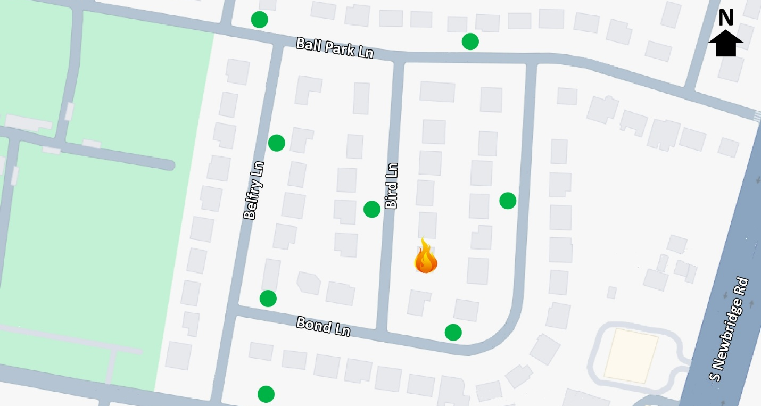
Note: Adapted from Google. (2025a). [Map, 17 Bird Lane, Hicksville, NY]. Map data ©2025 Google. https://bit.ly/4qupkP4.
The closest hydrant is to the north of the incident location on Bird Lane and additional hydrants are in the area as illustrated in Figure 1.
Figure 2. Aerial View
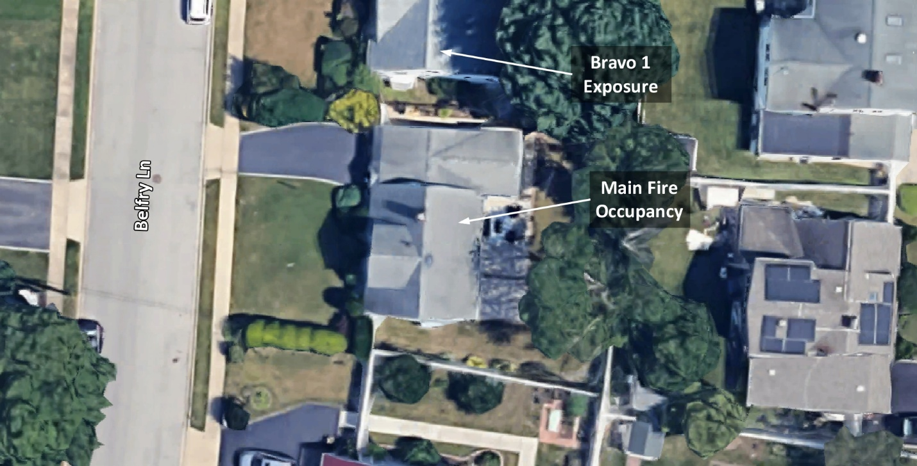
Note: Adapted from Google. (2025b). [Aerial view 17 Bird Lane, Hicksville, NY]. Imagery © Google, Imagery © Airbus Maxar Technologies, Map Data © 2025. https://bit.ly/3WzfttK.
Figure 3. Alpha/Delta Corner
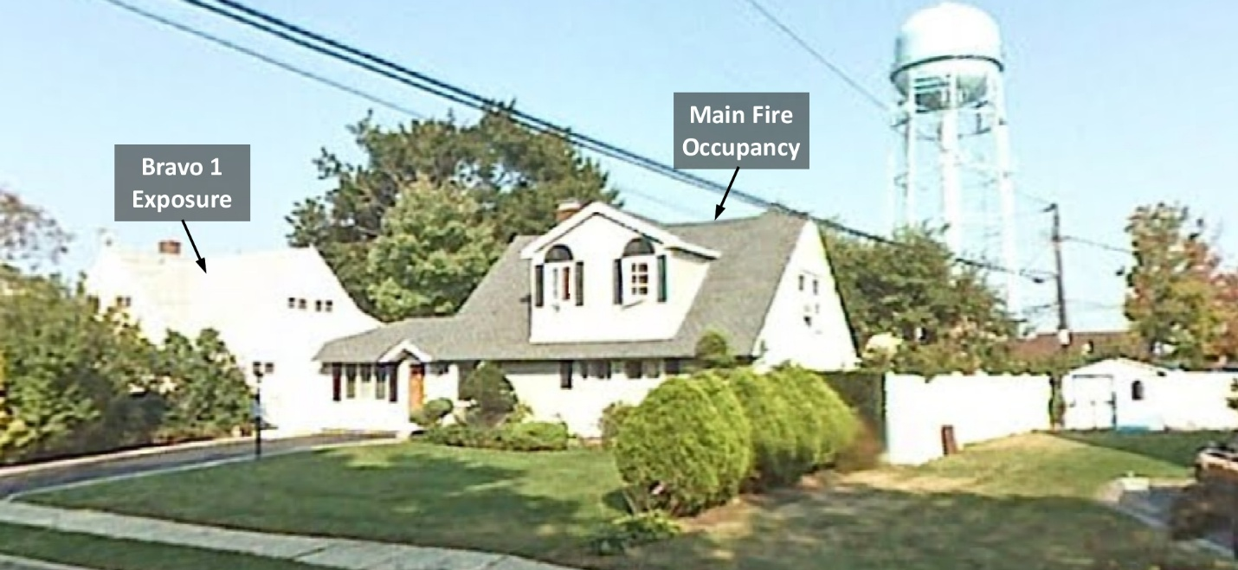
Note: Adapted from Google. (2007a). [Street view 17 Bird Lane, Hicksville, NY]. ©2025 Google. https://bit.ly/43bxzpf.
Figure 4. Side Alpha
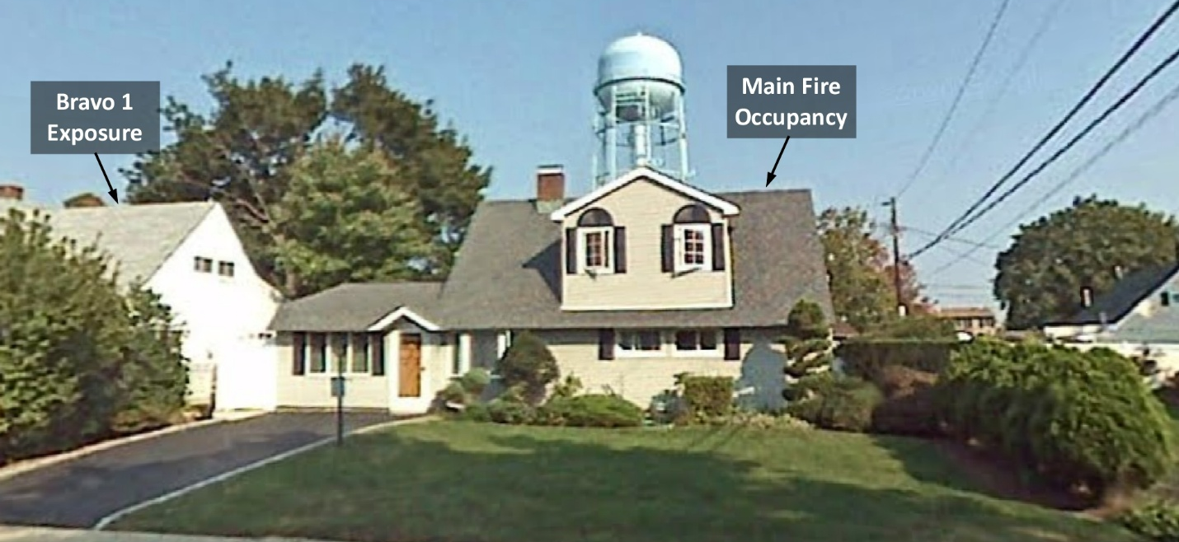
Note: Adapted from Google. (2007b). [Street view 17 Bird Lane, Hicksville, NY]. ©2025 Google. https://bit.ly/3JFHBZ9.
Figure 5. Alpha/Bravo Corner
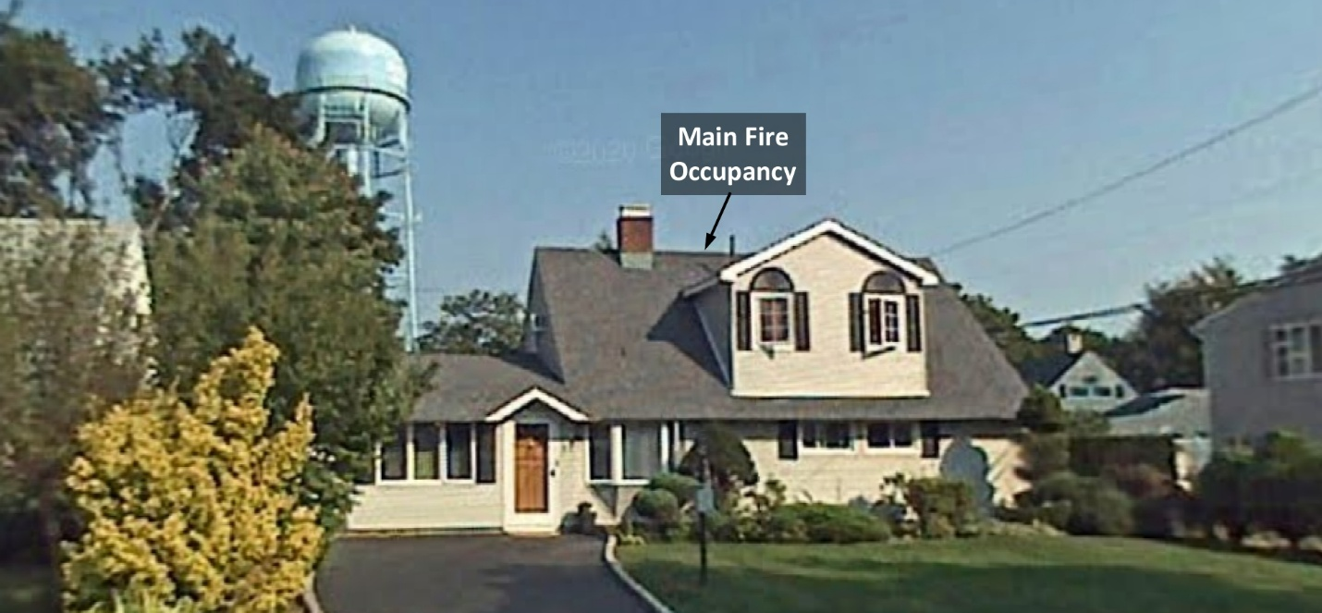
Note: Adapted from Google. (2007c). [Street view 17 Bird Lane, Hicksville, NY]. ©2025 Google https://bit.ly/3LEb9H7.
Figure 6. Charlie/Delta Corner 3D Aerial View
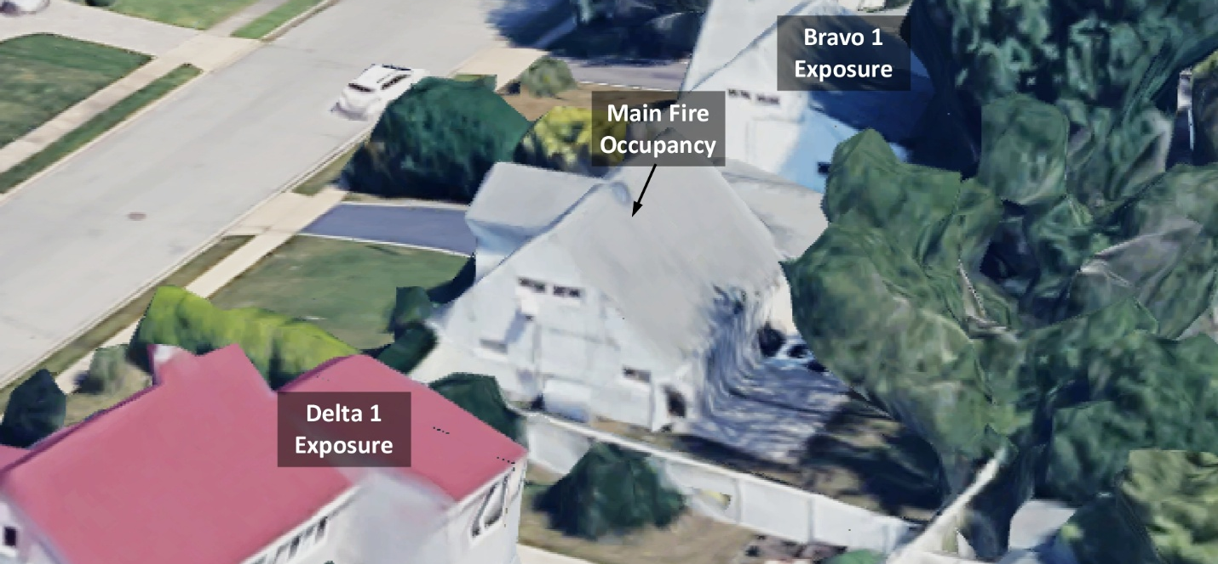
Note: Adapted from Google. (2025c). [3d aerial view17 Bird Lane, Hicksville, NY]. Map data ©2025 Google https://bit.ly/4qEU7ZI.
This area of the community is characterized by older, well established real estate, predominantly owner occupied, single-family homes. Residents in this part of the community are affluent and predominantly employed in white collar professions. The community is highly diverse with White Non-Hispanic, Asian, and Hispanic as the major racial and ethnic distribution. There are a significant number of households in the community that speak languages of India at home. Median age in the community is approximately 42 and median household size is 3.26. This area of the community does not experience an unusual level of fire activity and intentional fires are infrequent (Google, 2025d).
The temperature is currently 69º F with wind from the west at 3 mph (Weather Underground, 2025). You are the company officer of an engine company. It is Thursday, September 11th, and you are dispatched to 17 Bird Lane along with two other engines, a ladder company, medic unit, and command officer for a residential fire at 19:23. The engines and ladder have four-person staffing.
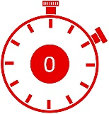 | Time starts now! Answer the first eight questions within the next 10 minutes. Decide and put your answers in the form of communication you would have with your crew, other companies, and the first arriving command officer. Save discussion for after answering these eight questions.
- What critical factors would you consider when dispatched and during response? What conversations would you have with your crew during response?
While responding, you hear the other engines, ladder, medic unit, and command officer go enroute and dispatch provides an update that the fire is on the second floor.
You approach this incident from the south on Bird Lane. You anticipate the ladder company will arrive two minutes after you, followed by the second arriving engine and command officer. Watch the incident video (DB200 Fire Photography, 2025) from 00:30 to 00:37 and examine Figure 7 illustrating conditions on arrival.
Figure 7. Conditions on Arrival
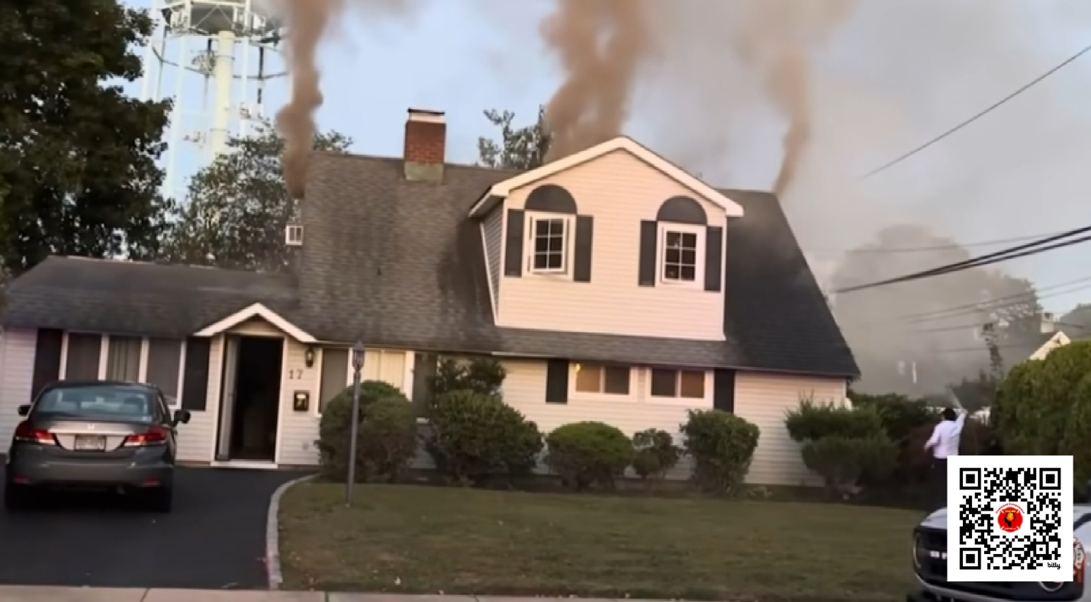
Note: Adapted from DB200 Fire Photography. (2025). *Pre arrival* Hicksville F.D. responds to a working house fire! https://bit.ly/43m06bX
- State your initial radio report (IRR) exactly as you would transmit it to dispatch.
- What specific actions would you take (as the company officer) immediately upon arrival and exiting the apparatus and what task orders would you give your crew?
Conditions on Sides Bravo and Charlie are consistent with those observed from Side Alpha. There is a small amount of flame visible near the weather head of the electrical power drop on Side Delta.
- Would you change the action you are taking or modify the assignments given to your crew? If so, what task orders would you provide?
- State your follow up report exactly as you would transmit it to dispatch.
- Ladder 1 arrives and reports that they are Level 1 at Belfry Lane and Bond Lane. State the tactical assignment you would give them exactly as you would transmit it.
- Engine 2 arrives and reports that they are Level 1 on a hydrant at Belfry Lane and Bond Lane. State the tactical assignment you would give them exactly as you would transmit it.
- Based on anticipated effectiveness of your tactical operations, state your conditions, actions, and needs (CAN) report that you would provide to the first arriving command officer as part of command transfer to IC #2.
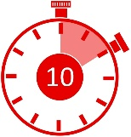 | Reflect on your strategic decision-making and responses to questions one through eight before answering the next six questions. Think about what cues, patterns, or anomalies (differences from conditions that you would anticipate) inform your answers.
- What was the problem?
- What was getting in the way of achieving your tactical priorities?
- Was there anything in this incident that could have hurt or killed you (right now)?
- Was it reasonable to believe that the exposures were occupied?
- Was there searchable space?
- If you believed it was reasonable that there was searchable space, what could you do about it?
The remaining questions are based on actual incident operations. In this incident, a command officer arrived shortly before the first arriving engine and provided an initial radio report indicating a working fire. Watch the first three minutes of the incident video (DB200 Fire Photography, 2025) before answering the remaining questions. | 
- Based on the building, environment, smoke, air track, heat, and flame (BE-SAHF) fire behavior indicators what conditions would you anticipate finding on the first and second floors?
- What building construction factors would you anticipate impacting on fire development, extension and firefighting in this incident? What impact would they have?
- If the fire originated from an electrical short in the electrical utility power drop (either at the weather head or elsewhere in the power drop) what avenue of fire extension into the structure would you anticipate?
- Prior to the line being stretched around Side Charlie to the exterior on Side Delta two members (one appearing to be a command officer) entered the house and completed a search and left the front door open. While leaving this door open did not appear to change the fire behavior indicators in the video, what impact could this have had on fire development?
- If your company was tasked with primary search and checking for extension, how would you approach this tactical assignment?
Additional Learning: Review the Electrical Safety Handbook for Emergency Responders (Hydra One Networks, Electrical Safety Authority, Office of the Fire Marshal, and Public Services Health and Safety Association, 2013) and discuss the electrical hazards that may have been encountered during this incident and how those hazards could be mitigated with the members of your crew. This Canadian handbook is an excellent resource examining electricity, electrical distribution systems, and electrical hazards.
Read Engine Essentials: Extinguishing Knee Wall Fires (Hall, 2023) and watch the three videos on how Attack Spikes (small piercing nozzles) can be used for fires involving attics and knee walls. Discuss your tactical alternatives if a fire behind knee walls has not yet extended into the living spaces. Consider how you would determine the extent and location of the fire, water application, and ventilation.
References
Broadcastify. (2025a). Nassau County Fire - East 09/11/2025 07:03 PM <--> 07:33 PM EDT. Retrieved November 1, 2025, from https://bit.ly/4hAv9qa.
Broadcastify. (2025b). Nassau County Fire - East 09/11/2025 07:33 PM <--> 08:03 PM EDT. Retrieved November 1, 2025, from https://bit.ly/4qD8EVz.
DB200 Fire Photography. (2025). *Pre arrival* Hicksville F.D. responds to a working house fire! [video]. Retrieved November 9, 2025, from https://bit.ly/43m06bX.
Flashpoint Fire Equipment. (2020). [Applications for using attack spikes for attic fires, web page]. Retrieved November 11, 2025, from https://bit.ly/4nQBzTF.
Google. (2007a). [Street view 17 Bird Lane, Hicksville, NY]. ©2025 Google. Retrieved November 11, 2025, from https://bit.ly/43bxzpf.
Google. (2007b). [Street view 17 Bird Lane, Hicksville, NY]. ©2025 Google. Retrieved November 11, 2025, from https://bit.ly/3JFHBZ9.
Google. (2007c). [Street view 17 Bird Lane, Hicksville, NY]. ©2025 Google. Retrieved November 11, 2025, from https://bit.ly/3LEb9H7.
Google. (2025a). [Map, 17 Bird Lane, Hicksville, NY]. Map data ©2025 Google. Retrieved November 11, 2025, from https://bit.ly/4qupkP4.
Google. (2025b). [Aerial view 17 Bird Lane, Hicksville, NY]. Imagery © Google, Imagery © Airbus Maxar Technologies, Map Data © 2025. Retrieved November 11, 2025, from https://bit.ly/3WzfttK.
Google. (2025c). [3d aerial view17 Bird Lane, Hicksville, NY]. Imagery © Google, Imagery © Airbus Maxar Technologies, Map Data © 2025. Retrieved November 11, 2025, from https://bit.ly/4qEU7ZI.
Google. (2025d). Sociodemographic profile of the neighborhood surrounding 17 Bird Lane, Hicksville, NY [Gemini AI response, November 10, 2025]. Unpublished raw data.
Hall, J. (2023) Engine essentials: extinguishing knee wall Fires. Retrieved November 11, 2025, from https://bit.ly/4oyvpIP.
Hydra One Networks, Electrical Safety Authority, Office of the Fire Marshal, and Public Services Health and Safety Association. (2013). Electrical safety handbook for emergency responders. Retrieved November 11, 2025 from https://bit.ly/43WTSiN.
Overtheedgephoto. (2025). [Instagram post]. Retrieved November 1, 2025, from https://bit.ly/3JGznzY.
Weather Underground (2025). Farmingdale, NY weather history [historical weather September 11, 2025]. Retrieved November 9, 2025, from https://bit.ly/3WOfXMF.

If your first alarm deployment is different, use your own resource assignment and staffing.

